**Dafuqs an algorithm?**

Basically, a bundle of code that takes an input – like a number – and does some fancy math on it and spits it out as an output.

Let it be noted that there is no limit for how much code an algorithm can consist of. A giant motherhubbard of a program can be called an algorithm, as long as the purpose of said program is just to get an input, math the hell out of it, and then give an output.

**Datastructure?**

Organization of stored data, as well as how to handle it.

**Task 1 – Pseudocode for finding 2 smollest numbers.**

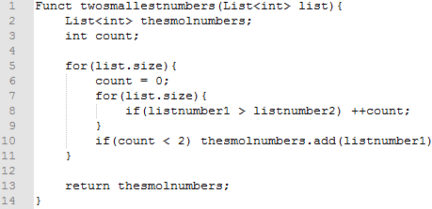

Runtime: $n^{2}$ (Worst case) (This was badly made btw, don’t use it as reference)

**Task 2 – Pseudocode for reversing an array**

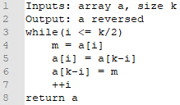

Runtime: $\frac{n}{2}$

**Task 3 – Do two arrays have exact same contents???**

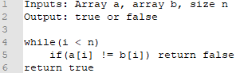

Runtime: $n$ (Worst case)

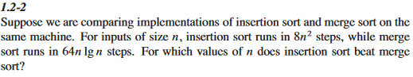

Around >1.16